Go to Dev.twitter.com

Click Sign in

Click “My Applications”

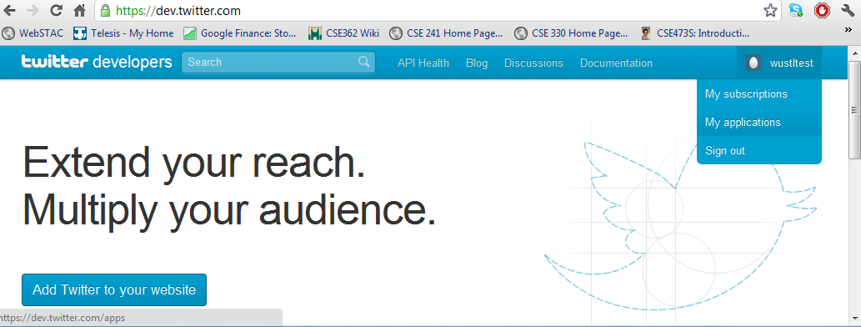

Click “Create a New Application”

Fill out the form and click “Create your Twitter Application”

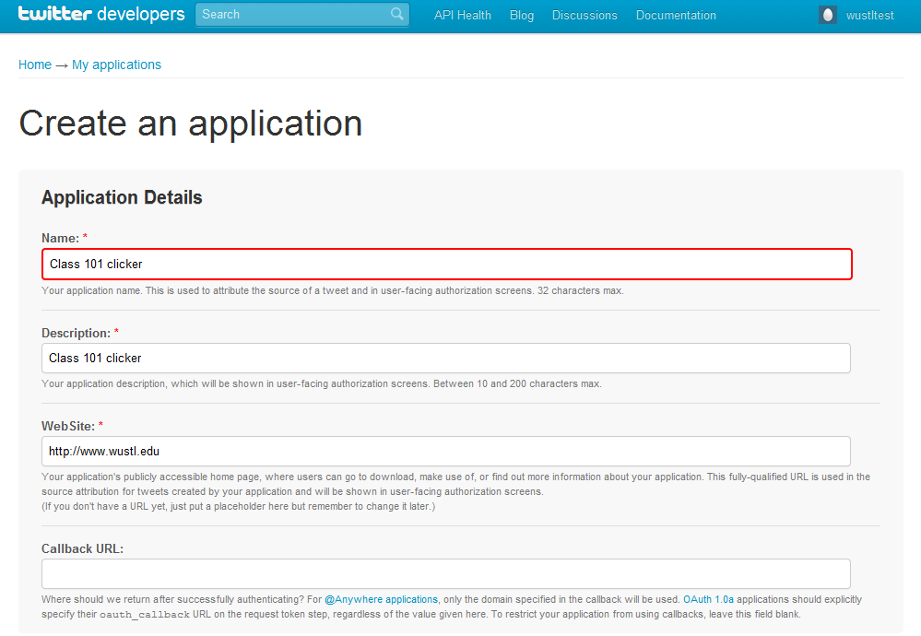

Click “Settings”

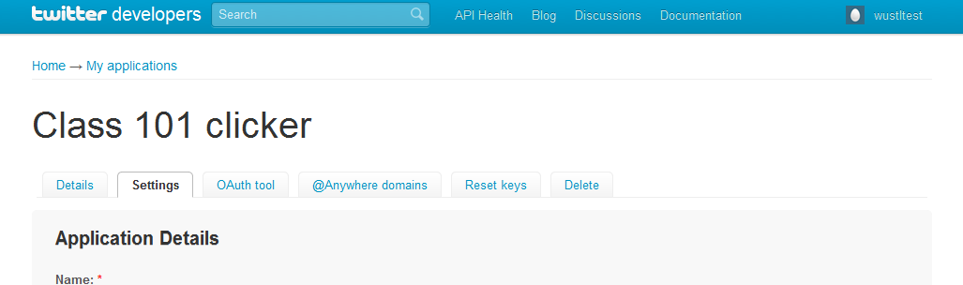

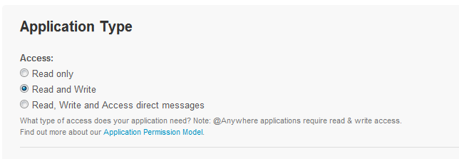Scroll down to the middle of the page, and change your application type to “read, write, and access direct messages”

Click “Update this Twitter Application’s Settings”

Change tabs back to “Details”

Click “Create my access token” at the bottom of the page

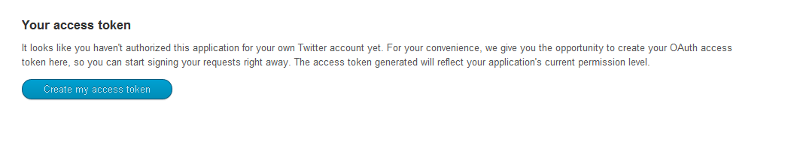

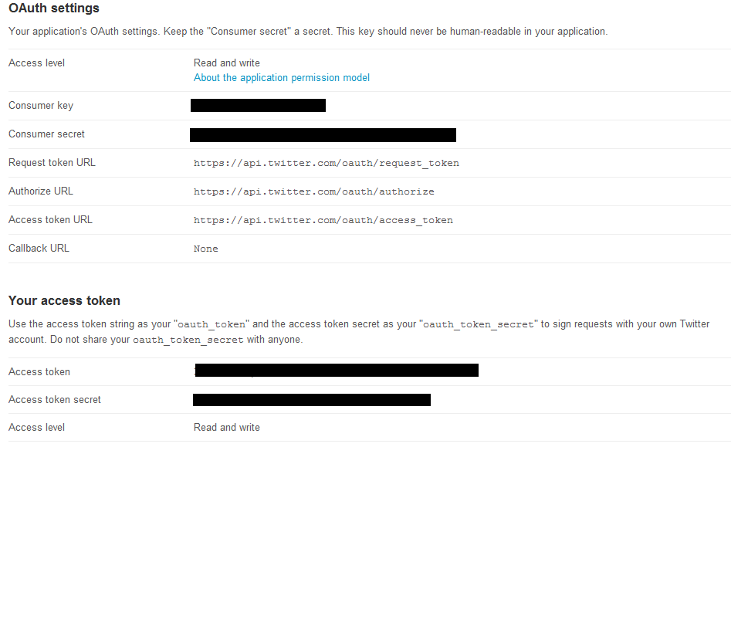All four of the tokens will now be available on the page.